Crunch
A game based on the food chain and creatures from the Clark Fork Watershed.
For 3 to 5 players.

Objective:
Crunch you way to the top of the food chain by collecting all the cards.

Contents:
- 5 Bald Eagle Cards
- 10 Bull Trout Cards
- 11 Minnow Cards
- 8 Macroinvertebrate Cards
- 5 Plankton Cards
- 2 Pollution Cards
- 4 Rainstorm Cards

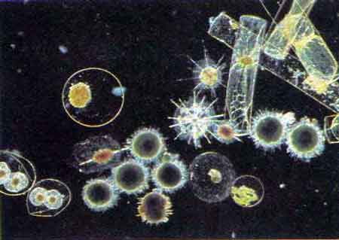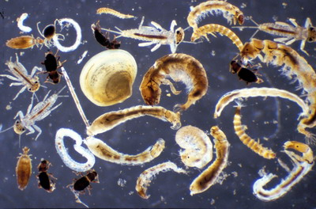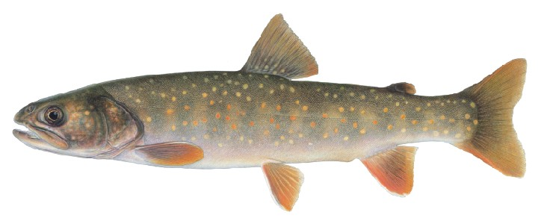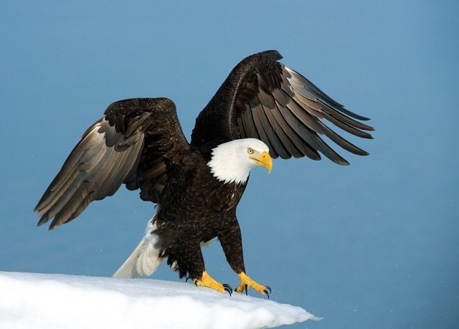Cards and Crunching order:

- Bald Eagle (can crunch Bull Trout, Minnow, Macroinvertebrate and Plankton)
- Bull Trout (can crunch Minnow, Macroinvertebrates, and Plankton)
- Minnow (can crunch Macroinvertebrates and Plankton)
- Macroinvertebrate (can crunch Plankton)
- Plankton (can’t crunch anything)

Action Cards:
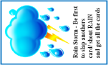
- Rain Storm Card: Be the first player to slap another card and shout Rain and you get all the cards.
- Pollution Card: All cards get set aside.
Game:
- Become familiar with crunching order (Bald Eagle, Bull Trout, Minnow, Macros, Plankton) and special cards.
- Remove explanation cards.
- Shuffle the deck and deal the cards equally to each player (place any remaining cards to the side).
- In unison, all player turn over the top card in their pile.
- The first player to slap the card lowest in the food chain and shout CRUNCH wins the round. The winner collects all the cards that their card can crunch and places them in their discard pile. If your card couldn’t be crunched place it in your discard pile. (NOTE: if the lowest card is yours you cannot crunch)
Example:
-Four players turn over a Bald Eagle, Bull Trout, Bull Trout and Minnow. Only the Bald Eagle and the Bull Trout can crunch (since the minnow is the lowest on the food chain). The player that slaps the minnow card and shouts CRUNCH wins the round. If the player that slaps the minnow card is the player with the Bald Eagle Card they would collect all the cards. If the player that slaps the minnow card is the player with the Bull Trout card they would collect the minnow card and the other players would put their card in their discard piles.

- Play continues and all players turn over the next card in their pile.
- When your pile runs out, shuffle your discard pile, place it face down in front of you and continue playing.

BAD CRUNCHES
- Slap another player’s card that is higher on the food chain.
- Slap another player’s card that is the same as yours.
- Slap your own card.
If you make a bad crunch put the top card of your pile face down in the playing area. The winner takes both of your cards along with any they other card they crunch. If there is no winner of the round, your card stays in the center and the winner of the next round takes the card.

Possible Scenarios:
- All cards turned over are the same.
  - Since you cannot eat your own kind, each player puts their card in the discard pile.
- All but one player turn over the lowest creature on the food chain.
  - The player with the highest creature on the food chain takes all the other cards.
- Both pollution and a rain storm card are played.
  - Pollution prevails and all cards are set aside.
Breaking a Tie
If two or more players crunch at the same time, set aside the cards. Each player then plays the next card in their deck. The first to slap the lowest card and shout CRUNCH wins all the cards. They also get all the cards from the previous round that they could crunch. The ones they can’t crunch are given to the player of the cards to place in their discard pile.

Ending Game
If all your cards get chomped you are out of the game. Keep playing until only 2 players have cards. The players then count their cards and the winner is the player with the most cards.

Resources for pictures:
Bald Eagle: http://mnh.si.edu
Bull Trout: http://www.fs.fed.us/r6/fishing/regional/fishresources/images/bull.jpg
Minnow: http://fwp.mt.gov/mtoutdoors/images
Macroinvertebrates: http://www.nzfreshwater.org
Plankton: http://oceanworld.tamu.edu/students/fisheries/fisheries2.htm
Pollution: http://www.dostquangtri.gov.vn; http://www.enviroblog.org/pollution.jpg

